Turnitin plugin for ILIAS 4.2 & 4.3 (Administrator instructions)

# Setup

## Installation Instructions

Unzip the plugin and copy all the files to the following path:

Customizing/global/plugins/Services/Repository/RepositoryObject/TurnitinAssignment

Go to the “Plugins, Modules and Services” section in ILIAS administration, the TurnitinAssignment plugin should be listed alongside the Plugin Slot: RepositoryObject.

Click “Administrate” to go to the Plugin administration screen (fig. 1), under Status click “Update”. This will install the plugin, you must then click “Activate” which appears under Status to activate the plugin. This process is the same when updating to a newer version of the plugin.

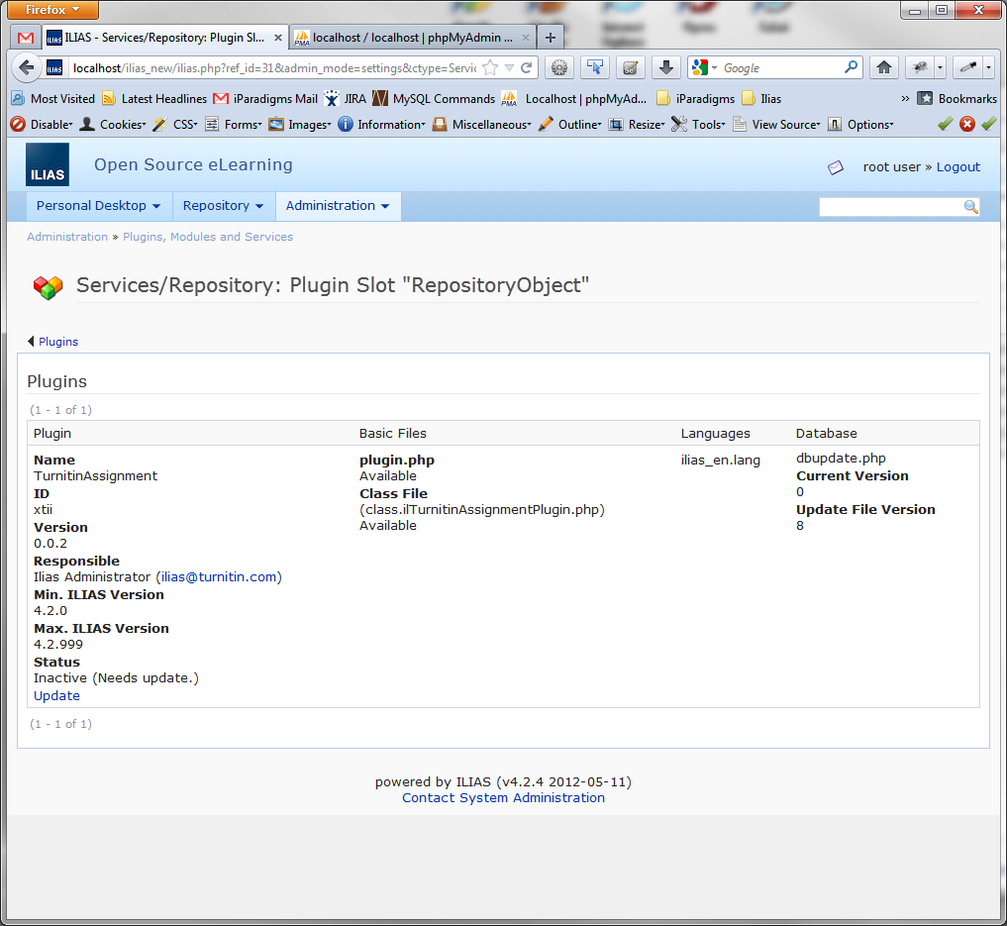

Fig. 1

## Requirements

You must be running ILIAS version 4.2 or later.

For this plugin to work, support must be enabled for cURL in your php.ini file. To do this, locate either one of the following lines in your php.ini file:

;extension=php_curl.dll  
;extension=php_curl.so

Remove the semi-colon at the start of the line to activate the php cURL extension. Once you have done this you will need to restart your web server service.

More information on cURL and more detailed instructions for installing it can be found here:

<http://uk3.php.net/curl>

You must also have javascript enabled in your browser else this plugin and Turnitin will not work correctly.

## Permissions

By default ILIAS will not allow a course tutor to create an assignment, if you wish to allow this you will have to edit the permissions for this role in the Roles section under Administration.

## Configuration

Go to the “Plugins, Modules and Services” section in ILIAS administration and click “Administrate” to go to the Turnitin Assignment Plugin administration screen (fig. 1).

If you have downloaded any new or updated language packs, click “Refresh” under Languages to refresh the plugin’s language settings.

Under Status, click “Configure” and you will be taken to the Plugin Configuration screen (fig. 2).

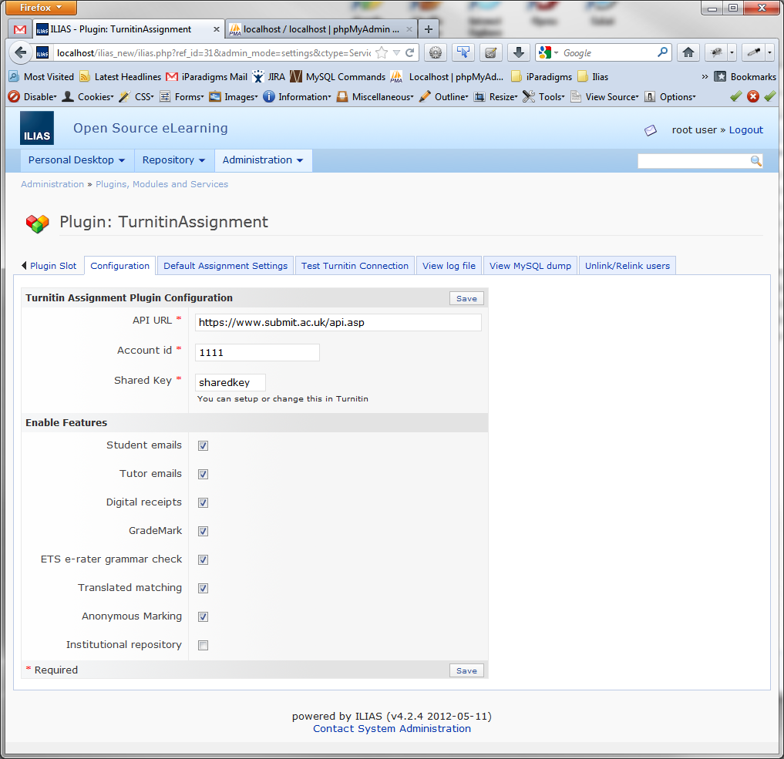

Fig. 2

The API URL and Account id will have been supplied to you separately by Turnitin, while the shared key must match the shared key that you have setup in your Turnitin account.

By default, emails and digital receipts are turned on. These can be toggled on/off here.

Tutors will receive emails when:

* They are registered with Turnitin
* They are joined to a course
* A Member joins their course

Members will receive emails when:

* They are registered with Turnitin
* They are joined to a course

Digital receipts are sent to a member when a paper has been received by Turnitin.

The other features mentioned; Grademark, ETS e-rater, Translated Matching, Anonymous Marking and Institutional Repository must be enabled in your Turnitin account for you to use them. If they are enabled in ILIAS but not in your Turnitin account you may experience errors.

## Troubleshooting

Go to the “Plugins, Modules and Services” section in ILIAS administration and click “Administrate” to go to the Turnitin Assignment Plugin administration screen (fig. 1).

Under Status, click “Configure” and you will be taken to the Plugin Configuration screen (fig. 2).

Clicking the “Test Turnitin Connection” tab will attempt to connect to the Turnitin API, a message will be returned as to whether this attempt was successful or otherwise.

The “View log file” tab displays a log of calls to the Turnitin API over the last 20 days. This will display any errors returned by Turnitin along with any relative successful messages returned such as when an assignment is created.

The “View MySQL dump” will show a data dump of the database which will help you link courses, assignments and papers to each other.

The “Unlink/Relink users” tab gives you a table of users along with their Turnitin id if they are linked to Turnitin. You can unlink and link any user to Turnitin from here.

# Functionality

## Creating an Assignment

An assignment can only be created within a course, click “Add New Item” and select “Turnitin Assignment” from the drop down list. You will be prompted to enter a title and description for the new assignment, then on clicking “Save” you will be taken to the settings screen (fig. 3).

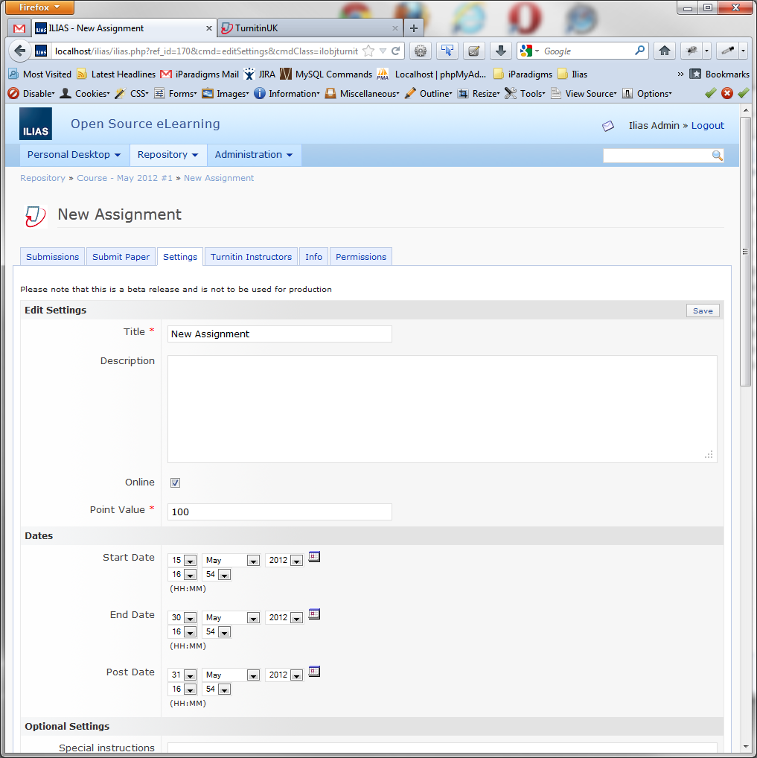

Fig. 3

Here you can configure your assignment with all the relevant options available in Turnitin.

## Viewing Submissions

Clicking on the relevant assignment or clicking on the “Submissions” tab when logged in as a tutor or admin will take you to the submissions screen (fig. 4).

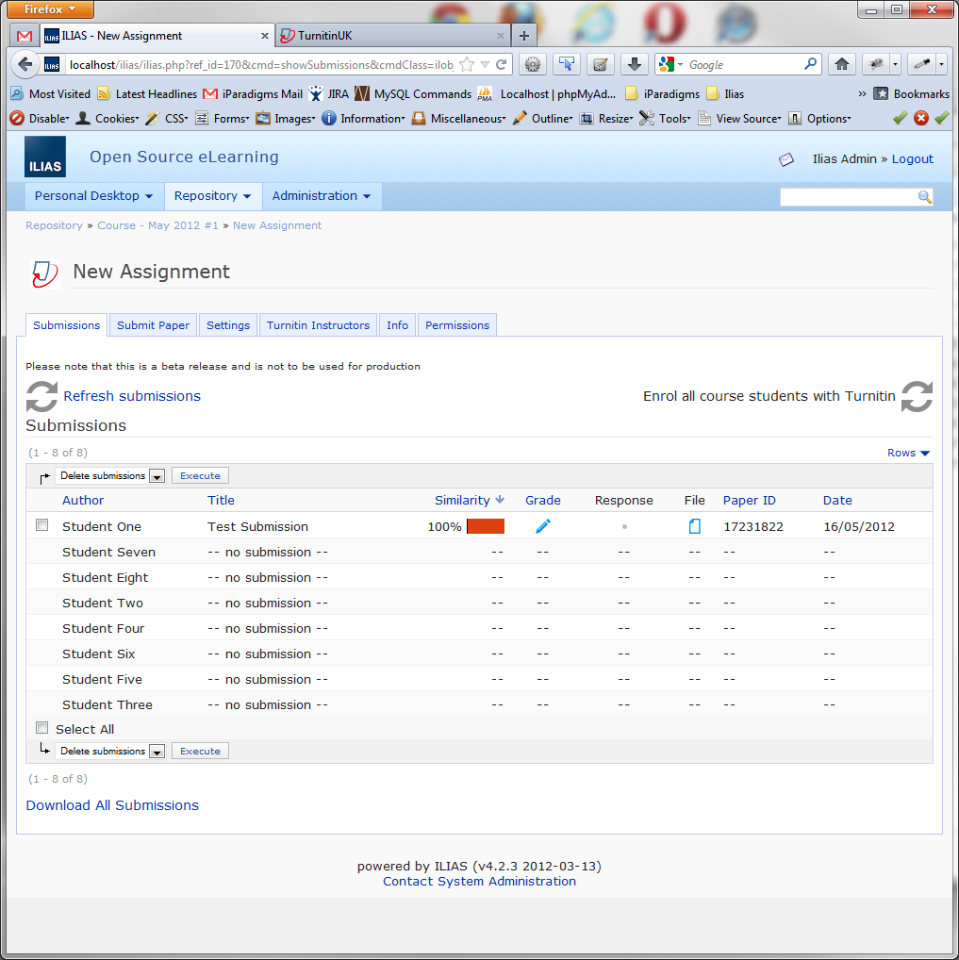

Fig. 4

Here you will find the result of the originality report and the grade awarded (if Grademark is enabled). Submissions can also be deleted from Turnitin or the original file downloaded if required.

## Submitting a Paper

To submit a paper to the assignment, click on the “Submit Paper” tab while viewing the relevant assignment and you will be taken to the submit paper screen (fig. 5). Users who are tutors or administrators can submit on behalf of a student by selecting them from the drop down menu.

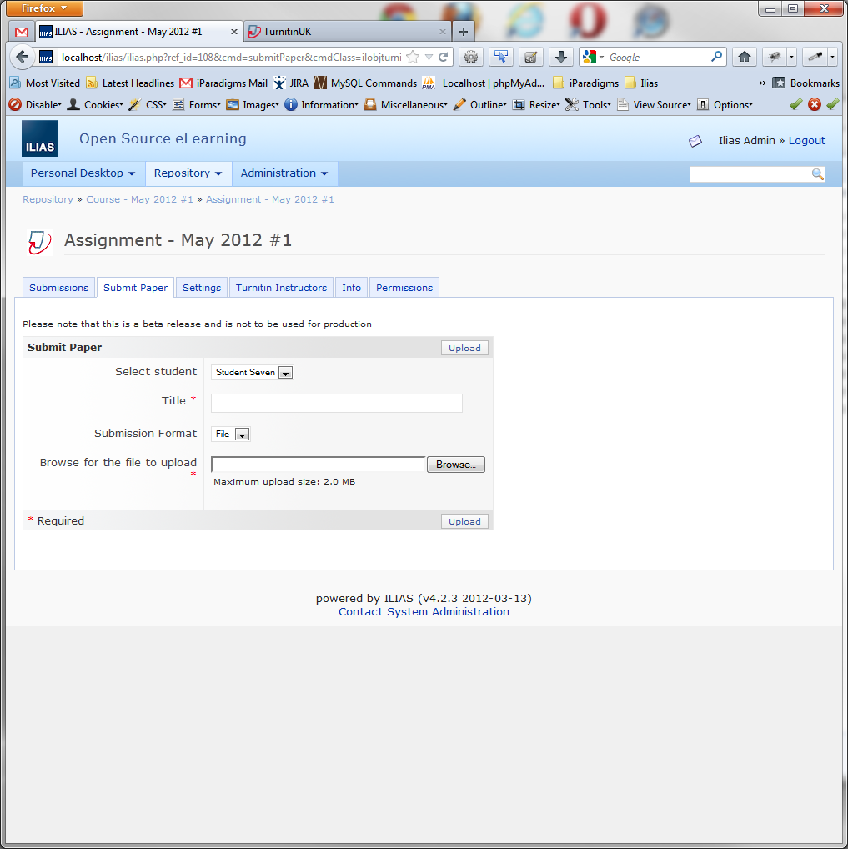

Fig. 5

Depending on the assignment’s settings a paper can be submitted in text format or as a file.

## Student’s View

When a student is logged in they will see a different screen with the assignment’s details (fig. 6).

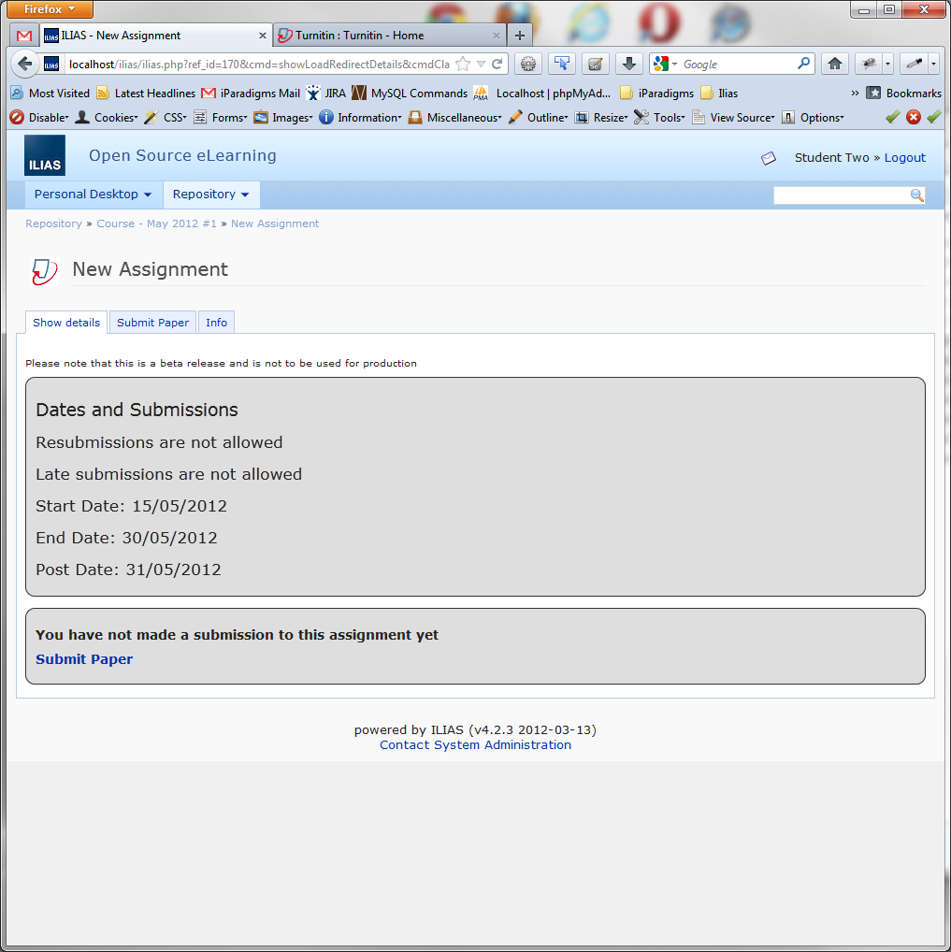

Fig. 6